Briefcase-style Drone Locator

Technical specifications v1.0

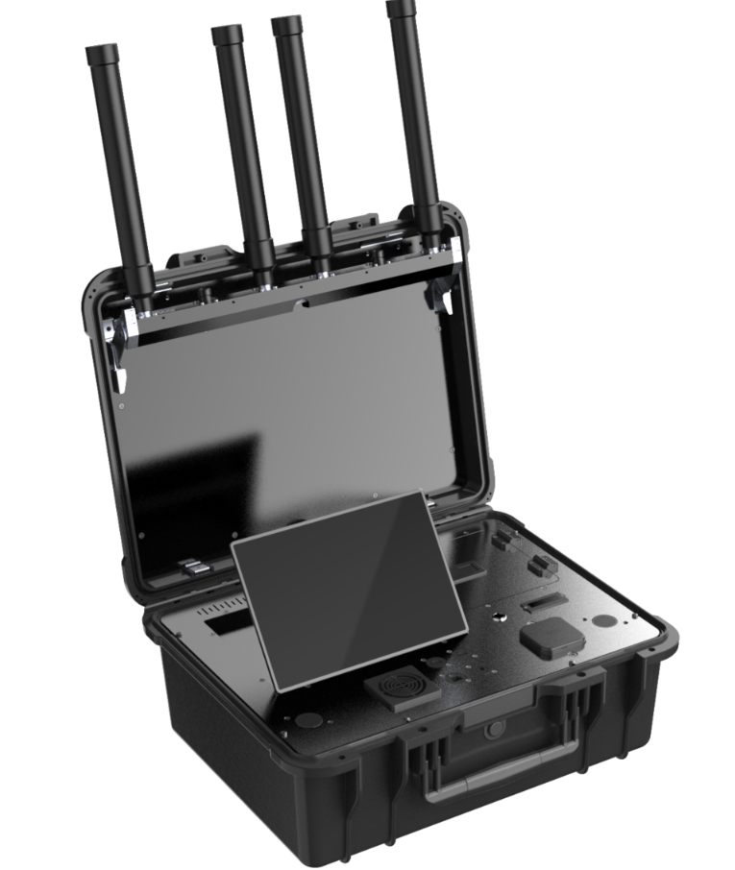
Product Name: Briefcase-style Drone Locator
Product model: CH11 Pro

catalogue
Briefcase-style Drone Locator I
Technical specifications v1.0 I
I. Product Overview 1
II. Product composition 1
III. Product Features 1
IV. Product Features 3
V. Product indicators and parameters 4
5.1 Performance indicators 4
5.3 Electrical characteristics 5
5.4 Environmental adaptability 5
5.5 Touch screen parameters 6
VI. Safety standards 6
6.1 Electromagnetic compatibility 6

I. Product Overview
The CH11 Pro portable Drone detection and positioning system, powered by its integrated control software and hardware platform, enables real-time monitoring of Drone parameters including serial numbers, models, coordinates, speed, altitude, flight paths, and pilot positions through advanced signal analysis and data mining. It also significantly enhances detection capabilities for FPV Drones, effectively identifying low-frequency band aircraft models.
The equipment is suitable for low-altitude security in major event security and guard tasks, public security patrol, special duty counter-terrorism, political core area, border defense, military restricted area, military management area, electric power petrochemical park and other scenarios. It can work offline on a single machine, flexibly and quickly deploy, and respond to mobile, so as to meet the needs of various scenarios.

II. Product composition
The product is mainly composed of three parts: the main engine, detachable battery and power adapter, as shown in the following table:
Table 1 Product hardware composition details
number | device name | quantity | unit
1 | Device Host | 1 | pcs
2 | Battery | 4 | pcs
3 | Power adapter | 1 | pcs

III. Product Features
- Drone monitoring: can obtain the serial number, model, position (latitude and longitude, azimuth), speed, altitude, take-off point, return point, track, remote control position (latitude and longitude, azimuth) of the Drone within the monitoring range;
- Unique identity code identification^{[1]}: can identify the unique serial number of the Drone and confirm the unique identity information of the Drone;
- Drone positioning ^{[2]}: can locate the position information of the Drone, display the position (latitude and longitude), orientation information and distance information (the distance between the Drone and the equipment) in real time;
- Flyer positioning ^{[3]}: can locate the position information of the flyer, display the position (latitude and longitude), orientation information and distance information (the distance between the flyer and the equipment) in real time;
- Multi-target trajectory tracking ^{[4]}: can track the positioning of Drone swarm and display multiple flight trajectories of Drone;
- Black and white list ^{[5]}: can distinguish cooperative and non-cooperative Drones, the device does not give an alarm when cooperative Drones are detected, and can mark trust for cooperative Drones;
- Intrusion alarm: when the device detects the intrusion of a Drone, it will sound or light alarm;
- Track playback ^{[6]}: Support Drone flight trajectory playback to assist security personnel to analyze historical Drone flight data;
- Detection records ^{[7]}: The detection records list can retain historical detection records, including multi-dimensional information such as Drone serial number, model and frequency;
- RID monitoring ^{[8]}: equipped with RID identification function and supports a variety of standard protocols.
- Data visualization analysis: support for Drone detection and flight data statistical analysis, can be presented by heat map, line chart and other visual icons;
- Electronic map: Electronic map switching, including Gaode, Baidu and Google;
- Cross-terminal connection: The display system interface can be connected through mobile terminals (mobile phones, computers, etc.), so that security personnel can search for the location of pilots and Drones through mobile terminals.
- Source detection: the equipment does not emit any electromagnetic signal, no electromagnetic pollution, environmental friendly;
[1]-[7] can be identified as DJI series models using OcuSync map transmission mode.
[8] GB 42590-2023、ASTM F3411 Remote ID、ASD-STAN prEN 4709-002

IV. Product Features
- Complete range of detection models: the system can identify and detect most common brand Drones such as DJI, Autel Robotics, FIMI ,Yuneec and other self-made Drones such as cross Drones and WiFi Drones;
- Long detection distance: in open environment, the detection distance of some models can reach more than 10km;
- Software and hardware integration: equipped with the integrated control platform of Drone, the single machine works independently without the need to configure other equipment;
- FPV detection: the new upgraded low-frequency detection capability can effectively improve the detection of FPV models;
- Portable: suitcase-style portable design, small size, carry around;
- Touch interaction design: adopt large screen touch design, simple operation, fast and convenient;
- Double power supply design: the equipment can be powered by detachable batteries or external power supply, adapting to multiple scenarios;
- Convenient deployment: The device antenna adopts the foldable storage design, which can be unfolded and retracted quickly, and can be switched on and off with one button to use it at any time.

V. Product indicators and parameters

5.1 Performance indicators
Table 2 Product performance indicators
number | metric | parameter | remarks
1 | Detect and identify Drone types | DJI, Autel Robotics, FIMI ,Yuneec and other common brand Drones and other homemade crosser planes, WiFi aircraft and most other models on the market
2 | Positioning Drone  type | DJI and other models
3 | Detected frequency band (Hz) | 300M~1.5G、2.4G、5.2G、5.8G | Expandable
4 | Detection and positioning distance | Urban environment 0.5~5km  The empty environment can reach 10km | There are some differences between environments and models
5 | Detection height | 0m～1000m
6 | The number of targets can be detected simultaneously | ≥20 flights
7 | The Drone's trajectory can be tracked simultaneously | ≥5 entries
8 | azimuth error | ≤1.5°（RMS）
9 | positioning accuracy | ≤10m
10 | Detection success rate | ≥99%
11 | Expand deployment time | ≤90s | The device is expanded and enters the working state
12 | Equipment withdrawal time | ≤30s
13 | Identification response time | ≤5s
5.2 Mechanical parameters
Table 3 Mechanical parameters of products
number | metric | parameter | remarks
1 | weight | ～19.5kg | Contains battery
2 | size | (520mm*415mm*224mm)±2mm | Box closed

5.3 Electrical characteristics
Table 4 Electrical characteristics of products
number | metric | parameter | remarks
1 | Overall power consumption | ≤100W
2 | External power supply voltage | 100～220V AC
3 | duration of flight | ～4 h | Battery power supply

5.4 Environmental adaptability
Table 5 Environmental adaptability
number | metric | parameter | remarks
1 | working temperature | -20～65℃
2 | storage temperature | -40～70℃
3 | levels of protection | IP65 | Box closed

5.5 Touch screen parameters
Table 6 Touch screen parameters
number | metric | parameter | remarks
1 | screen size | 10.1 inch
2 | screen resolution | 1080P（1920*1200）

VI. Safety standards

6.1 Electromagnetic compatibility
The equipment complies with the following electromagnetic compatibility standards:
GB/T 17626.2-2018 Electromagnetic Compatibility Test and Measurement Technology Static Discharge Immunity Test
GB T 17626.3-2006 "Electromagnetic Compatibility Test and Measurement Technology-RF Electromagnetic Field Radiation Immunity Test"
GB T 17626.4-2018 "Electromagnetic Compatibility Test and Measurement Technology-Test of Disturbance Resistance of Electrical Fast Transient Pulse Group"
GB T 17626.5-2019 "Electromagnetic Compatibility Test and Measurement Technology Surge (Impact) Immunity Test"
GB T 17626.6-2017 "Electromagnetic Compatibility Test and Measurement Technology-Conducted Noise Immunity Test in Response to RF Field Induction"
GB T 17626.11-2008 "Electromagnetic Compatibility Test and Measurement Technology Voltage Sudden drop, short time interruption and voltage change immunity test"
All of the above tests were performed at a severity level 3.

